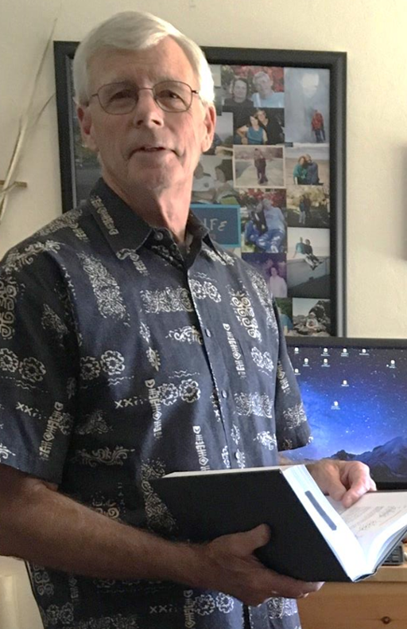

Dr. John (“Jack”) Campbell

CONTACT INFORMATION

2136 Westbrook Lane
Livermore, CA 94550

Cell: 925-784-5441
email: campbelljh@comcast.net

ABOUT JACK

Jack Campbell is founder of Material Science Solutions (MSS; established. 2007), a small high-tech company specializing in advanced laser materials and materials processing R&D. MSS serves private sector business clients in aerospace, laser processing, optical materials and micro/nano fabrication.
Prior to starting MSS, Jack was a member of the senior scientific staff at Lawrence Livermore National Lab (LLNL) where he spent more than 30 years developing optical materials for use on high-energy/high-peak-power lasers. He was lead scientist for optical materials and optical fabrication for the 10MJ, 500TW Nd-glass laser system of the National Ignition Facility (NIF) commissioned in 2007.
Jack is a recipient of the International Otto-Schott Research Award for innovative research on glasses and glass-ceramics (1999) and the American Ceramic Society’s (Optical Glass division) George Morey award for research on laser glasses (2003). He has received four R&D100 awards (1987, 1988, 2001 and 2007) for inventions of new optical materials and processes. Jack received his PhD degree in Physical Chemistry from the University of Illinois at Champaign-Urbana.

BACKGROUND:

Founder/owner: Material Science Solutions:

Material Science Solutions (Livermore CA), founded in 2007, provides both on-site and off-site engineering and scientific support to solve challenging materials and materials processing problems for customers in aerospace, laser, energy, bio-material and other high tech industries. The company addresses problems involving all four major classes of materials: glasses, ceramics, polymers and metals.

Education:
Ph.D. Physical Chemistry; University of Illinois, Urbana Illinois (1975)
B.S. Chemistry; Rochester Institute of Technology, Rochester NY (1970)
R&D:
Thirty-plus years of experience developing novel materials and material processing technologies for photonics, energy and aerospace applications.

Business and Management:
Twenty five years of experience leading large (100+), medium (10-30) and small (3-10) cross-disciplinary project teams in R&D efforts to design, develop and manufacture advanced material processing systems.
Ten years as owner/operator of a profitable small high-technology business.

EXPERIENCE AND ACCOMPLISHMENTS:

I. Material Science Solutions
April 2007 – present: Owner
Capitalized and launched a profitable small business specializing in solving laser materials and materials processing problems for high-technology clients.
Resident Emeritus Scientist
Provide scientific support to NIF and other LLNL projects on an as needed basis.

II. Lawrence Livermore National Laboratory (1975-2008)

2005 – 2008; Chief Scientist: Advanced Optical Materials and Processing:
Developed next-generation optical materials for high power lasers including advanced laser-gain media, novel glass compositions, glass property characterization, glass processing methods, and advanced crystal growth technology.

1999-2005; Project Manager-Laser Materials and Optics Technology:
Managed a 100-120 person team of scientists, engineers, technicians and support personnel responsible for $250 million multi-year effort to develop and deliver nearly 10,000 meter-scale optics for the world’s largest optical and laser system: The National Ignition Facility.

1990 – 1999: Senior Scientist-Optical Materials Research and Development:
Managed team of 30 (scientists, engineers and technicians) developing advanced optical materials and optical manufacturing methods.

1975-1990: Lead Scientist/Project leader
Lead investigator for chemistry, materials and materials processing R&D projects on a variety laser, nuclear, fossil energy, solar and military projects

KEY PATENTS (Processes and products that have been fully commercialized)

Y. T. Hayden, S. A. Payne, J. S. Hayden, J. H. Campbell, M. K. Aston, M. L. Elder, “Phosphate Glass Useful in High Energy Lasers”, U.S. Patent No. 5,526,369, June 11, 1996.C.

R. Wolfe, M. R. Kozlowski, J. H. Campbell, M. S. Staggs, and F. Rainer, “Permanent Laser Conditioning of Thin Film Optical Materials”, U.S. Patent No. 5,472,748, Dec. 5, 1995.

H. T. Powell, J. H. Campbell, M. O. Riley, C. R. Wolfe, R. Lyon, E. S. Jessop, and J. E. Murray, “Composite Polymer-Glass Edge Cladding for Laser Disks”, U.S. Patent No. 4,849,036. July 18, 1989.

SAMPLE PUBLICATIONS
L. J. Jiang, J. H. Campbell, Y.F. Lu, T Bernat and N. Petta, “Direct-writing target structures by two-photon polymerization”, Fusion Sci. and Tech., in press, (2016)

T.P. Bernat, J. H. Campbell, N. Petta, I. Sakellari, S. Koo, and C.P. Grigoropoulos, “Fabrication of Micron-scale Cylindrical Tubes by 2-Photon Polymerization”, Fusion Sci. and Tech., in press, (2016).

L. J. Jiang, J. H. Campbell, Y.F. Lu, T Bernat and N. Petta “Precision fabrication of laser targets: development of 2-photon polymerization as a next-generation tool” Published in the proceedings of the International Congress on the Applications of Lasers &Electro-optics (ICALEO), Oct 18-22, 2015.

J.H. Campbell, J. S. Hayden and A. Marker “High-Power Solid State Lasers: A Laser Glass Perspective”, Intl. J. Applied Glass Sci. (March 2011). P.R. Ehrmann, K. Carlson,

J. H. Campbell, C. A. Click and R. K. Brow, “Neodymium Fluorescence Quenching by Hydroxyl Groups in Phosphate Laser Glasses”, J. Non. Cryst. Solids, 349, (2004) p.105-114.

J. Campbell, “Glasses for High-Power/High-Energy Lasers”, Am, Ceram. Soc. Bull. May 2004, p.9101-9109.

P.R. Ehrmann, K. Carlson, J. H. Campbell, C. A. Click and R. K. Brow, “Neodymium Fluorescence Quenching by Hydroxyl Groups in Phosphate Laser Glasses”, J. Non. Cryst. Solids, 349, (2004) p.105-114.

C. A. Click, R. K. Brow, P. R. Ehrmann and J. H. Campbell, “Characterization of Pt4+ in Alumino-metaphosphate Laser Glasses”, J. Non. Cryst. Solids,319 (2003)p.95-108

P. R. Ehrmann and J. H. Campbell, “Non-Radiative Energy Losses and Radiation Trapping in Nd-doped Phosphate Laser Glasses”, J. Am. Ceram. Soc., 85 [5] 1061-69 (2002).

M. Karabulut, G. K. Marasinghe, C. A. Click, E. Metwalli, R. K. Brow, C. H. Booth, J. J. Bucher, D. K. Shuh, T. I. Suratwala, and J. H. Campbell, “XAFS Investigation of Platinum Local Environment in Phosphate Laser Glasses”, J. Am. Ceram. Soc., 85 [5] 1090-99 (2002).

J. H. Campbell and T. I. Suratwala, “Nd-doped Phosphate Glasses for HighEnergy/High-Peak-Power Lasers”, J. Non-Cryst. Solids, 263/264 (2000), p. 318-341.

J. H. Campbell, T. I. Suratwala, C. B. Thorsness, J. S. Hayden, A. J. Marker III, K. Takeuchi, M. Smolley, and G. Ficini-Dorn, “Continuous Melting of Phosphate Laser Glass”, J. Non-Cryst. Solids, 263/264, (2000) p. 342-357.

T. I. Suratwala, R. Steele, G. Wilke, J. H. Campbell, and K. Takeuchi, “Effects of OH Content, Water Vapor Pressure, and Temperature on Slow Crack Growth Behavior in Phosphate Laser Glass”, J. Non-Cryst. Solids, 263/264 (2000), p. 213-227.

