Manual for the Nd:YAG Laser
http://www.continuumlasers.com/products/pulsed_power_series.asp

- Startup Procedure:
  - Open city water and drain source connected to laser system.
  - Switch on electronics rack circuit breaker located on front upper right hand side of cabinet. The CG604C pump will also turn on.
  - Switch ON the 24V power supply switch located on rear of electronics cabinet.
  - Turn key on front panel of CU601C counter-clockwise to the ON position.
  - After approximately 15 seconds the control unit CU601C will complete its system check and countdown. The phrase MANUAL MODE is then displayed on the remote box RB601.
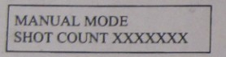
  - Press the AUTO/MANUAL key on the RB601 and then press the START key.
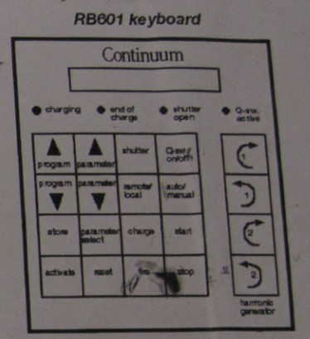
  - The system will cycle to programmed mode #1 (PGM1) for system warm-up. The laser heads should now be flashing at the standard rep rate.
  - Allow the system to run for 30 minutes without Q-switching to thermally stabilize the system.
  - Select desired programmed mode of operation by pressing the PRGRAM UP key on the RB601.
  - Once the PGM is located press ACTIVATE key to engage the desired PGM.
  - On the RB601 press on the keys SHUTTER and Q-SWITCH. The four LED’s across the top of the RB601 should be on or flashing.
  - Open desired wavelength port and maximize harmonic crystals if necessary.
B. Shutdown procedure
1) Press the STOP key on the RB601.
2) Close all wavelength ports.
3) Turn key on front panel of CU601C clockwise to the OFF position.
4) Leave the 24V power supply switch on rear of electronics rack in the ON position.
5) Switch off electronics rack circuit breaker located on front, upper right hand side of cabinet.
6) Close city water and drain source connected to laser system.
C. Programming the RB601 remote box
Through the RB601 you can access a total of 16 Programmed Modes (PGM). The first 3 PGM’s are set at the factory and cannot be changed. The remaining 13 PGM’s can be programmed by the user.
PGM-1 is used for system warm-up. The Q-switch cannot be turned on and the shutter cannot be opened.
PGM-2 is used to take single shot alignment burns at full energy. Q-switch timing and rep rate are optimized.
PGM-3 is used for standard full power operation. System Q-switches with every flash of the laser head.
PGM-4 to 16 can be programmed by user.

